Data Science Report - Group 03

Filipe Sousa 90714 JOÃO GUERREIRO 90734 MIGUEL ROQUE 90758

1. Data profiling – REVER e meter gráficos

**Dataset 1** has 299 records and 13 variables (there’s a ratio of **23** records/variable), DEATH_EVENT being the **target**. Python assumes that anaemia, creatinine_phosphokinase, diabetes, ejection_fraction, high_blood_pressure serum_sodium, smoking, time and DEATH_EVENT are represented by an int64 and age, platelets and serum_creatinine by a float64. However, by domain expertise, we know that anaemia, diabetes, high_blood_pressure, sex, smoking and DEATH_EVENT can be better represented as a boolean since they only assume 2 different values.

Concerning Data Distribution, for numeric variables we described them through its five-number summary, inspecting its range through the identification of its minimum and maximum values, along with other estimators, like the mean, standard deviation and other different percentiles. During our analysis we also did boxplots to better understand the range of each variable, after this it was clear that they had different scales.

Then we plotted the histograms of each variable to be able to visualize the distribution that better suited each (between Normal, Exponential and LogNorm distributions). For symbolic variables we made an analysis using histograms as well. We were also able to identify several outliers in our variables except for the time variable.

Regarding granularity, we studied the atomic granularity of each variable and also analysed what was the best granularity for each numeric variable that still made it possible to visualize its distribution. We also concluded that there isn't any hierarchy of concepts for the symbolic variables, either from data or domain knowledge.

To finish this data profiling, we analyzed the data sparsity and made a correlation analysis. In this dataset the variables have very little correlation (most correlation values are between 0.01 and 0.3, 0.53 being the highest). The only two pairs with maybe some relevance are {sex, smoking} and {time, DEATH_EVENT}. We removed the outliers, applied the same techniques and got slightly different results, but still very low correlation coefficients. After this analysis, we concluded that the dataset seems enough to cover the domain. If we consider only the domain ([max, min]) of the data without the outliers, the data is, for almost all pairs of variables, largely scattered around the domain, covering most of it.

**Dataset 2** has 8991 records and 1025 variables, 1024 of them being **binary molecular fingerprints** (bmf) and the target - the **experimental class** (exp) - which can be **positive** (**very toxic**) or **negative** (**not very toxic**). It has a ratio of approximately **8.772** records per variable.

Regarding the data distribution, 41 bmf variables have 1 as their mode, and the remaining 983 have 0. The exp class has “negative” as its mode. We reach to the conclusion that since we’re working with Boolean variables, the notion of outliers had no meaning, only of anomalies. All variables follow a Bernoulli distribution, since they are binary. Regarding data granularity, since all variables are binary, they have a granularity of 2, and don’t need any discretization. Regarding data sparsity, we consider it is not useful to generate scatterplots for this dataset, since all variables are binary. However, we found out that about 0.183% of the pairs of variables are missing at least one of the possible combinations ((0, 0), (0, 1), (1, 0) or (1, 1)). Also, there are many pairs of highly dependent variables. We can see that the pairs with the 3 highest correlations are (bmf760, bmf415) with 0.981484, (bmf872, bmf686) with 0.975299 and (bmf684, bmf261) with 0.972491.

Regarding missing values, after analysing, we discovered that both datasets have none.

1. Unsupervised
   1. Association Rules
      1. Data preparation.

In **Dataset 1,** we started by dummifying the ‘sex’ column in ‘sex_M’ and ‘sex_F’ in order to find patterns for women too. We also dummified each numeric variable into bins of equal number of records, with different numbers of bins. We will refer to these configurations as A and B onwards (A: 10 bins for ejection_fraction and 25 for all others, B: 5 bins for ejection_fraction and 10 for all others). In **Dataset 2**, we selected features with correlation less than 0.13, so the algorithm ran in our devices without crashing.

* + 1. Pattern mining

In Dataset 1, we used a min support of 0.001 and we found 242911 patterns with configuration A and 225851 with B. In Dataset 2, we had to increase min support to 0.004 due to computational resources, and we only found 4602 rules, most probably because the 175 remaining variables (after selection) had low correlation and thus have few implication relationships between them.

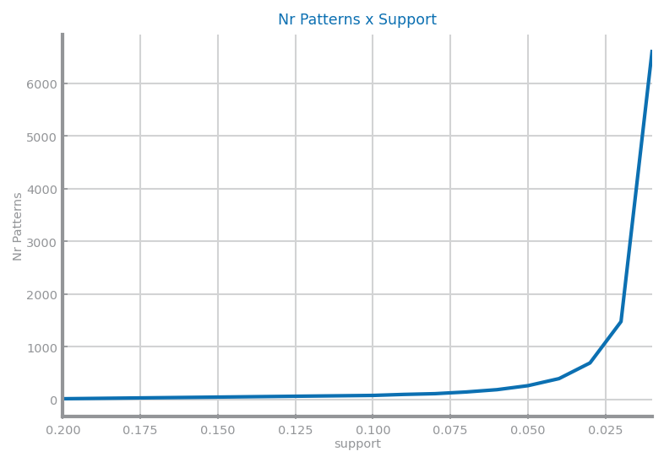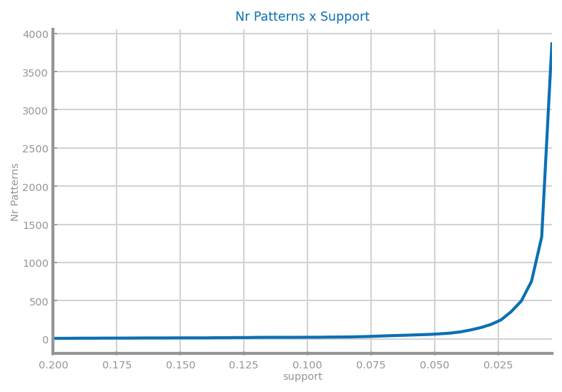

* + 1. Association rules

In Dataset 1, we found 11644889 association rules with configuration A and 9618208 with B. In Dataset 2, we found 4602 rules.

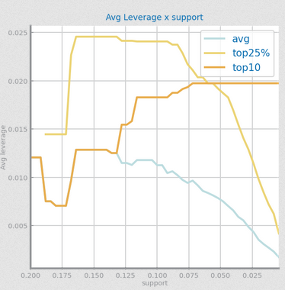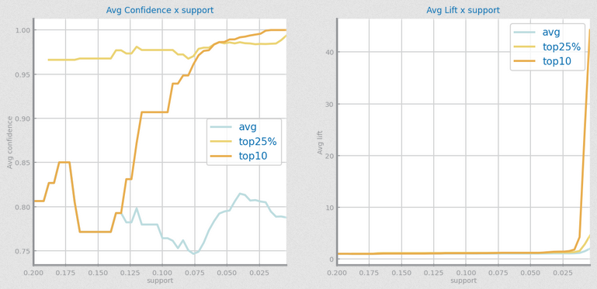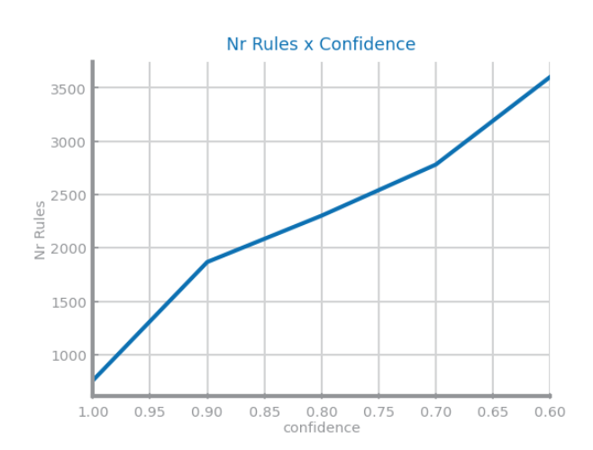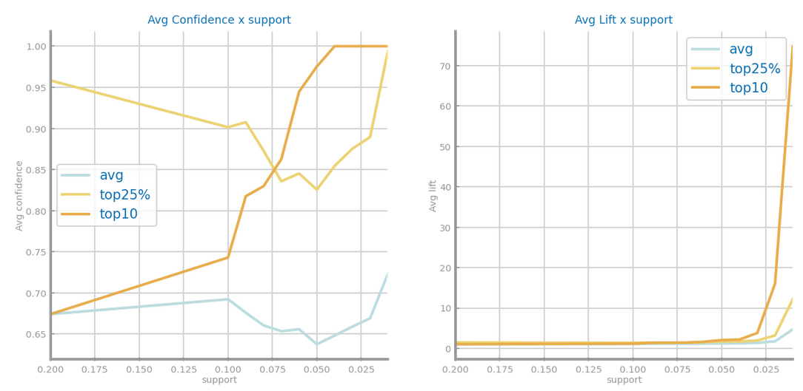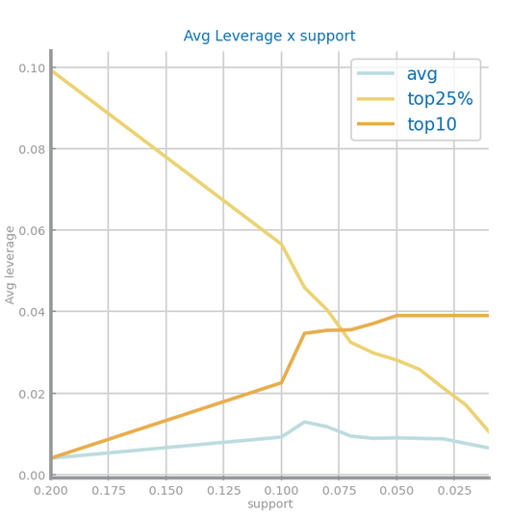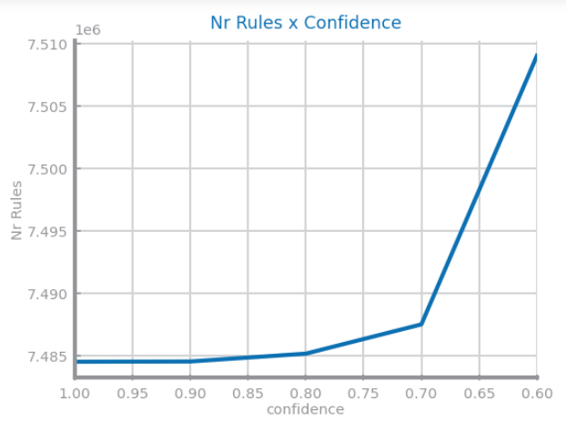







We didn’t show the top 3 rules for dataset 2 as they don’t have a very perceptible meaning.

* 1. Clustering
     1. Data preparation.

For Dataset 1 we tested with the raw data, the data after two types of scaling (minmax and zscore), and then added Feature Extraction (PCA) for the three just mentioned. For Dataset 2 we experimented with Feature Selection and with Feature Extraction. For each modified dataset obtained we applied several Clustering methods (K-means, Expectation Maximization, Density Based and Hierarchical). Feature Extraction theoretically may improve the clustering algorithms by generating features that produce better clusters.

* + 1. K-means

For dataset 1, without preparation, the variable “platelets” was having a high impact in the clusters’ formation due to its high scale. After scaling and FE, the clusters were more well defined, as we can see below (k=7 was chosen using the elbow method for MSE). For dataset 2, we present only the results after FE, as otherwise the variables are binary.

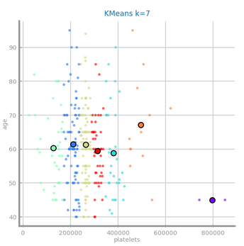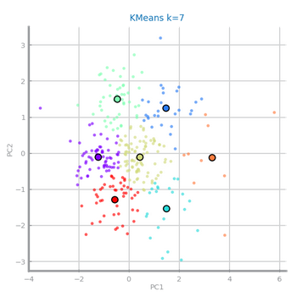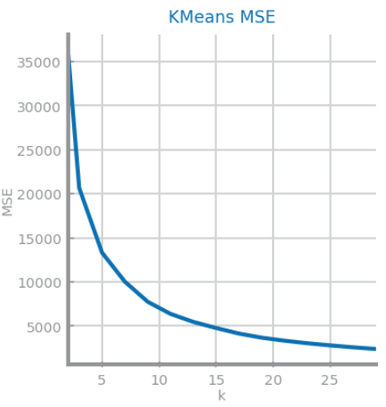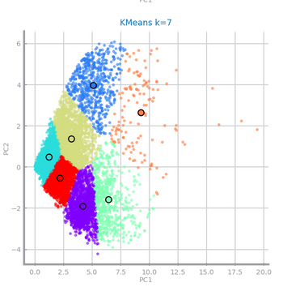

* + 1. Expectation Maximatizion

For both datasets, the results and plots were similar to K-means. For dataset 1, we compare MAE and MSE and conclude that they follow similar distributions. The chosen k was also 7 for both. For that k, the silhouette is around 0.35, and remains about the same for higher k. This can be due to the clusters being very close together, and thus increasing the number of clusters doesn’t increase their separability. We also computed Dunn coefficient, but its distribution was somewhat random and we couldn’t reach any conclusion.

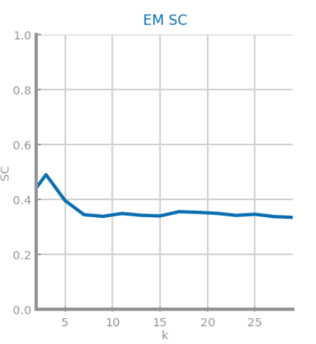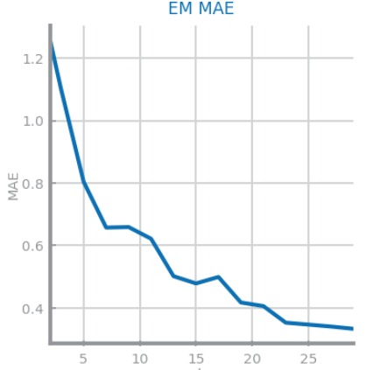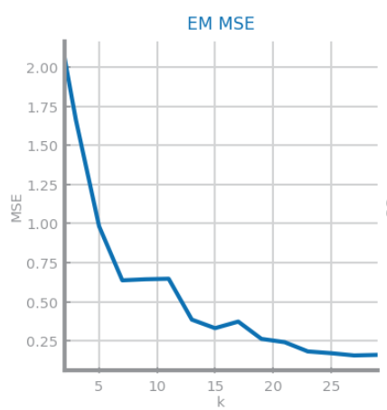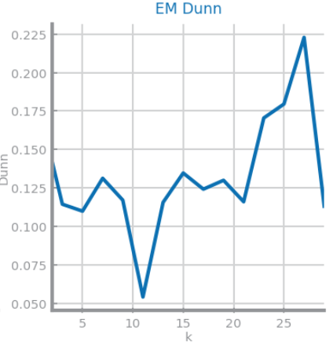

* + 1. Density Based

In

* + 1. Hierarchical

For both datasets, the cosine measure was usually the best. This can be seen in the bar chart for Davies-Bouldin index (for **Dataset 1**). We can also see that it presents lower values of MSE than most other metrics for both types of link (for **Dataset 2).**

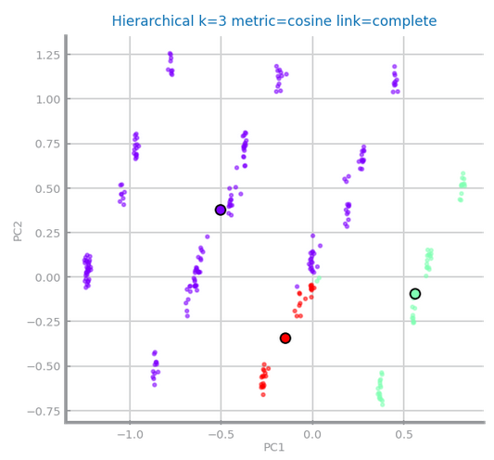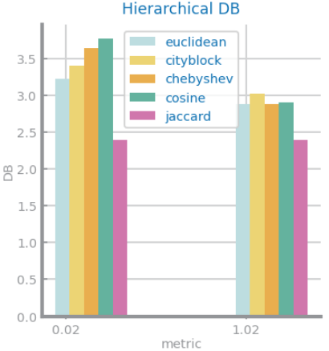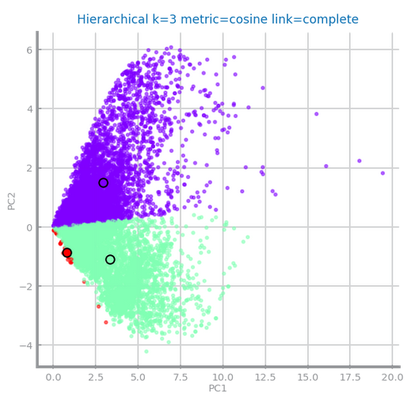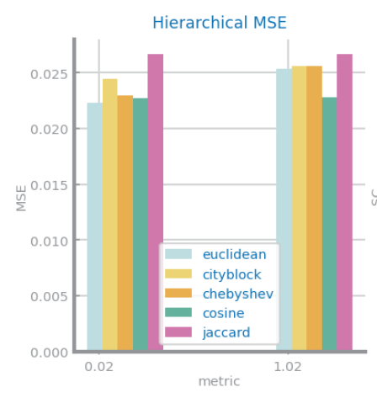

1. Classification
   1. Data preparation for Classification algorithms

The process of data preparation for the modified datasets used to test each algorithm is represented in general by the schemes below.

**We considered records as outliers if the value for one of its variables was outside the interval [(Q1 - 1.5 * IQR), (Q3 + 1.5 * IQR)]. For balancing, on dataset 1, we used SMOTE; on dataset 2 we did undersampling of the majority class (reduced it to 2/3 of the records) and oversampling of the minority class (to match the num. records of the majority class).

Figure ? Balancing Dataset 2

Figure ? Scalig Dataset 1

For FS, we used supervised methods (we removed features with less than 0.1 correlation to the target and then applied a select K-Best using chi-square with min chi-score 50) and unsupervised methods (we removed features with more than 0.8 correlation with at least one other feature). For FG, on Dataset 1, we did sum, product and difference of all pairs of numeric variables. For the last 3 algorithms, we didn’t use outliers’ removal since they shouldn’t affect trees. In all algorithms, except Decision Trees, we did Feature Extraction, using PCA. In dataset 1, although note referenced in the diagram, FG and PCA were always done after scaling, as the variables had very different ranges.

* 1. Training models

Based primarily on the size of the datasets, for Dataset 1 we used Stratified K-fold Cross Validation with 10 splits, and for Dataset 2 Hold-out (70% train / 30% test) without sampling, and for the preparation method with best results, with sampling (5 samples).

* 1. Evaluation metrics

For both datasets we used mean accuracy and recall, and 99% and 95% confidence intervals for accuracy in cases with multiple samples. We considered (besides accuracy) recall particularly important, as in both datasets it is important that the model is good at identifying true positives (death – Dataset 1, and toxicity – Dataset 2), as they have a higher impact than negatives, and thus need to be predicted with more certainty.

* 1. Algorithms
     1. Naïve Bayes

The z-score scaling, by assuming negative values, doesn’t work for MultinomialNB, and so we only considered minmax (mm) scaling. The best results for **Dataset 1** were obtained using the data with no outliers, no scaling, with balancing and feature selection and generation. In the next graph we present the accuracy score and confidence intervals of the several modified datasets we tried and the confusion matrix for the best result. The best estimator was Gaussian.

Figure 2-Mean and confidence intervals

Figure - Best Confusion Matrix

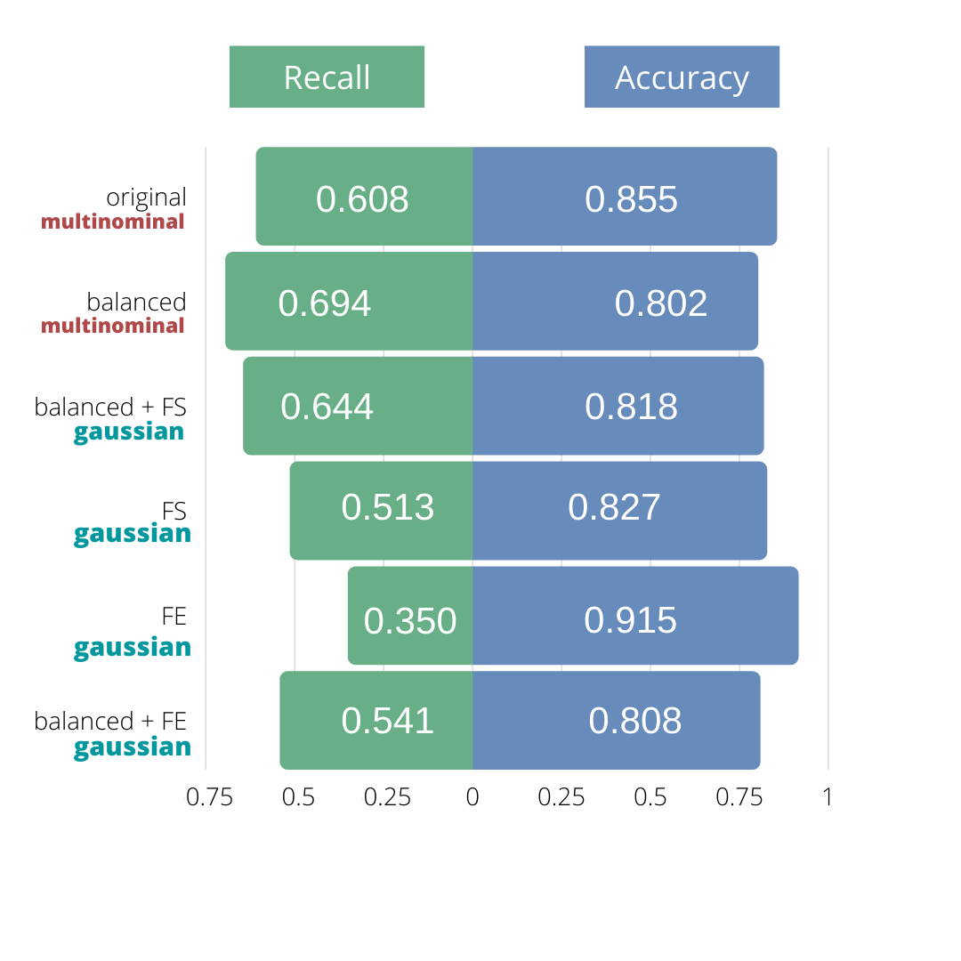For **Dataset 2** without balancing the accuracy is high but this is probably only because the original dataset has 8 times more False values than True values for the target variable and the classifier is marking almost everything as False as we can see in the first confusion matrix on Figure 3. Therefore, we also considered recall, and decided that the best results for this algorithm and dataset were with balancing only (Figure 4), that achieved accuracy of 0.802 with [0.*786*, 0.804] and [0.782,0.808] as 95% and 99% confidence interval respectively and using Multinominal. This can be explained by dataset2 being composed of multiple binary variables, and thus being well modeled by a Multinomial distribution. A bar chart of the best estimator, accuracy and recall is presented in Figure 5

Figure 5 – Evaluation metrics

Figure 4 – Balanced Confusion Matrix

Figure 3 – Unbalanced Confusion Matrix

* + 1. KNN

For **Dataset 1** the best results were achieved with z-score scaling, balancing and feature selection and generation. Regarding the distance measures, Manhattan and Chebyshev were the ones that showed better results. The best value for neighbours varied mostly between 5 and 9.

Figure 7-Mean and confidence intervals

Figure 7- Best confusion matrix

After looking at performance indicators, we concluded that, for **Dataset 2,** we got the best results with balancing only. Note that once again, the unbalanced data had higher accuracy but little true positives and therefore the model was useless given the domain of the problem. Manhattan was the measure with best results, 1 was the best number of neighbours. The mean accuracy after balancing only and its corresponding 95% and 99% confidence intervals are 0.894, [0.89,0.897], [0.889,0.899].

* + 1. Decision Trees

In Decision Trees the scaling had a really small impact in the results. This is likely due to scaling not changing the ordering between the values of each variable (and Decision Trees only have conditions of the form “>=”, “=” or “<=”). We omitted Feature Extraction, as the resulting trees would not have a useful meaning in the domain of the problems.

For **Dataset 1** we got the best results after **balancing** and **feature generation and selection**. The accuracies table can be found next as well as one of the best trees for one of the splits (which used gini criteria, max depth = 5 and min impurity decrease 0.02, yielding 0.939 accuracy). The accuracy for the best split was 1, although it doesn’t belong in the confidence interval for this preparation method, as seen below.

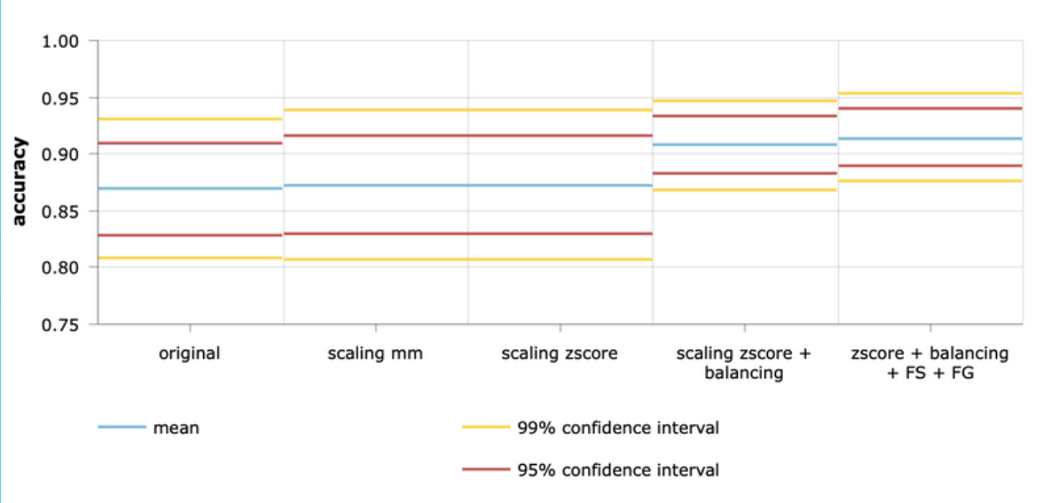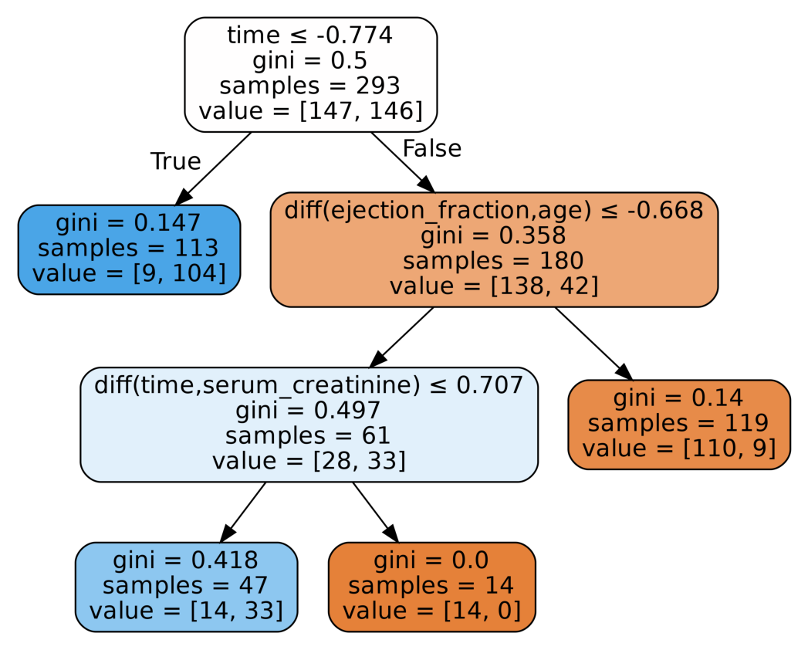//TODO ADD INFO ABOUT DEPTH AND OTHER PARAMETERS

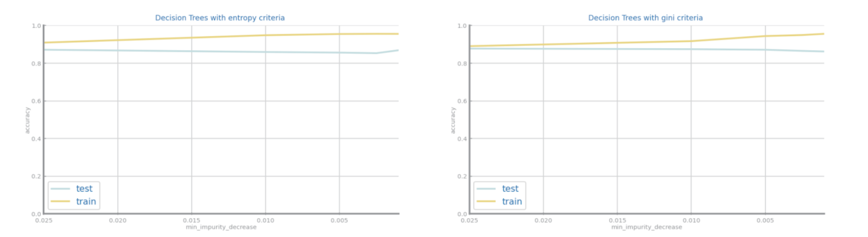Regarding Overfitting, we plotted the evolution of train and test accuracy and observed that the divergence of the values was small and therefore the overfitting didn’t have a noticeable relevance.

On **Dataset 2**, we opted to only explore the results in the modified datasets after feature selection, since the original data had a high number of variables. Considering this, the best accuracy was achieved without balancing. Though, after an overfitting analysis, the results seemed to be slightly overfit for min impurity decrease less that 0.0005, whereas with balancing the difference in performance between train and test sets is almost constant, ando so there is no overfitting (see Figure 2). The best performance achieved was with feature selection and balancing with gini criteria, the mean accuracy achieved and its corresponding 99% and 95% confidence intervals are 0.899, [0.888,0.911], [0.882,0.917].

Figure 4? – No overfitting after balancing

Figure ? - Unbalanced with overfitting

* + 1. Random Forests

In **Dataset 1** we got the best results with scaling and balancing with and without FG and FS. It’s relevant to observe that after FS and FG the algorithm was able to obtain almost the same results but with 3 less features.

The most common best max depth was 5, the best number of features varied mostly between 0.1 and 0.7 and the best estimators were most times 10 or 25.

After making an overfitting analysis we concluded that there is likely no overfitting since the train and test accuracies don't diverge.

In **Dataset 2** with original we got the best accuracy, however the recall was very low due to unbalanced data, and so we considered the best preparation for this dataset was the one with balancing only. The mean accuracy achieved along with its 95% and 99% confidence intervals are _ ,[___,____] ,[___,___].

No overfitting was found either as we can see in the graphs below. It is also curious that for max_depth = 5 the best forest classifies better the test than the train set.

* + 1. Gradient Boosting

For Gradient Boosting we experienced varying the maximum depth, learning rate and number of estimators. The best result for Dataset 1 were obtained with minmax scaling with and without balancing (see matrixes above). The mean, median and mode values for depth were 5.5, 5 and 5 respectively, for learning rate 0.38, 0.30 and 0.1, for n_estimators 91, 50 and 10. For the best of bests results (minmax scaling only) the accuracy and respective 99% and 95% confidence intervals were 0.903, [0.859,0.947] and [0.874,0.932].

Since the accuracy lines don’t diverge on the plot presented next, we assumed that the overfitting isn’t relevant even though test accuracy is lower than train accuracy.

For **Dataset 2** the best result was 0.951 of accuracy, with balancing and feature selection, depth of 25, learning rate of 0.7 and 300 estimators. The evolution of accuracy regarding those parameters can be seen in the graph next.

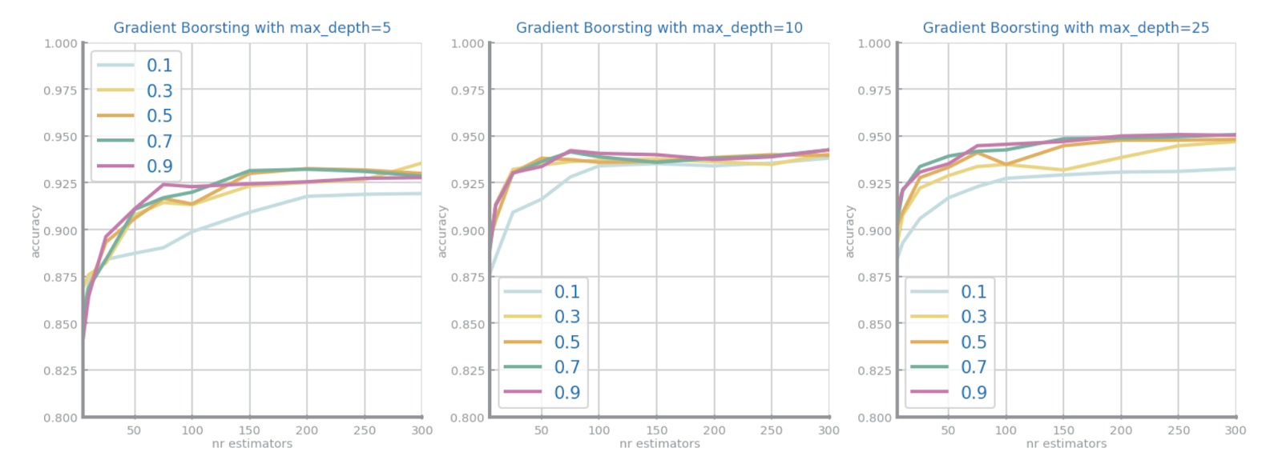

The other steps of preparation also achieved really high accuracy but only good recall if after balancing.

There seemed to be no overfitting also, after looking to the accuracy evolution in terms of max_depth and nr of estimators as we can see in the next plots.

1. Unsupervised

Although we didn’t have time to implement this strategy it came to our mind a classification method based on clusters that would work in the following way. We would start by using the results obtained on clustering to separate our data into clusters, next, for each cluster we would apply and choose the best classification algorithm for that specific data. Then, if we were giving a new record, we would only need to place it in a cluster and apply the classification method chosed for that specific cluster. This might be useful specially in the case where clusters don’t encapsulate well the values for target.

SEM ESPAÇO

Figure 1: Data distribution numeric variables